**Step 1:**

**Dockerize NodeJs & ReactJS application (must be multi-stage & lightweight docker image). Setup it on Linux System with docker-compose. Expose it via Nginx reverse proxy**

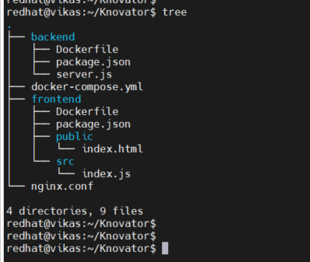

================================================>



================================================>

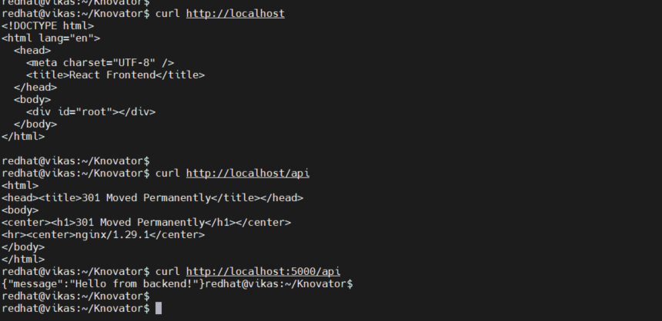

=======================================================>

Windows O/P:

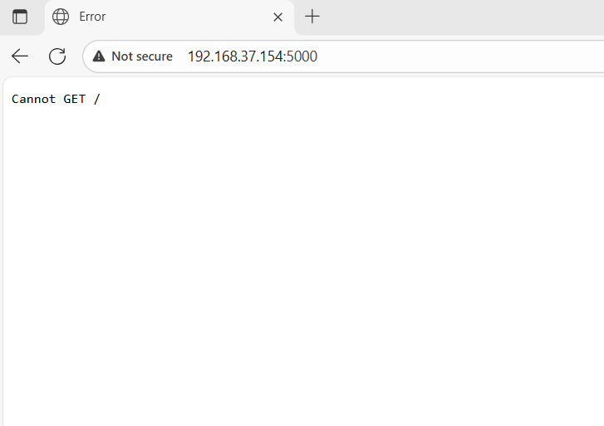

===========> /api

